Definite Numeral Adjectives

🔹 What Are Definite Numeral Adjectives?
# Source: AI Source: Provided by: [Data Path: Persons Table -> ID Column: 1, Name_En Column: Motasem Essam] -> From: [Chatgpt (GPT-4-turbo)] on [7/27/2025]
Definite numeral adjectives are adjectives that show an exact number or exact position/order of the noun they modify.
They clearly answer:
- 👉 How many? (cardinal numbers)
- 👉 Which position? (ordinal numbers)

✅ Types of Definite Numeral Adjectives
# Source: AI Source: Provided by: [Data Path: Persons Table -> ID Column: 1, Name_En Column: Motasem Essam] -> From: [Chatgpt (GPT-4-turbo)] on [7/27/2025]
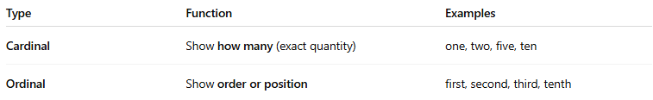
Type | Function | Examples
Cardinal | Show how many (exact quantity) | one, two, five, ten
Ordinal | Show order or position | first, second, third, tenth

📚 Examples in Sentences

🟩 Cardinal (Quantity):
# Source: AI Source: Provided by: [Data Path: Persons Table -> ID Column: 1, Name_En Column: Motasem Essam] -> From: [Chatgpt (GPT-4-turbo)] on [7/27/2025]
- I have two dogs.
- She bought five books.

🟦 Ordinal (Order):
# Source: AI Source: Provided by: [Data Path: Persons Table -> ID Column: 1, Name_En Column: Motasem Essam] -> From: [Chatgpt (GPT-4-turbo)] on [7/27/2025]
- He came first in the race.
- This is the third time I’ve called.

🧠 Key Points
# Source: AI Source: Provided by: [Data Path: Persons Table -> ID Column: 1, Name_En Column: Motasem Essam] -> From: [Chatgpt (GPT-4-turbo)] on [7/27/2025]
- Cardinal = Number
"Three students came late."
- Ordinal = Rank/Order
"The first student came early."
- They are called “definite” because they show clear, specific numbers (unlike "some" or "many").

